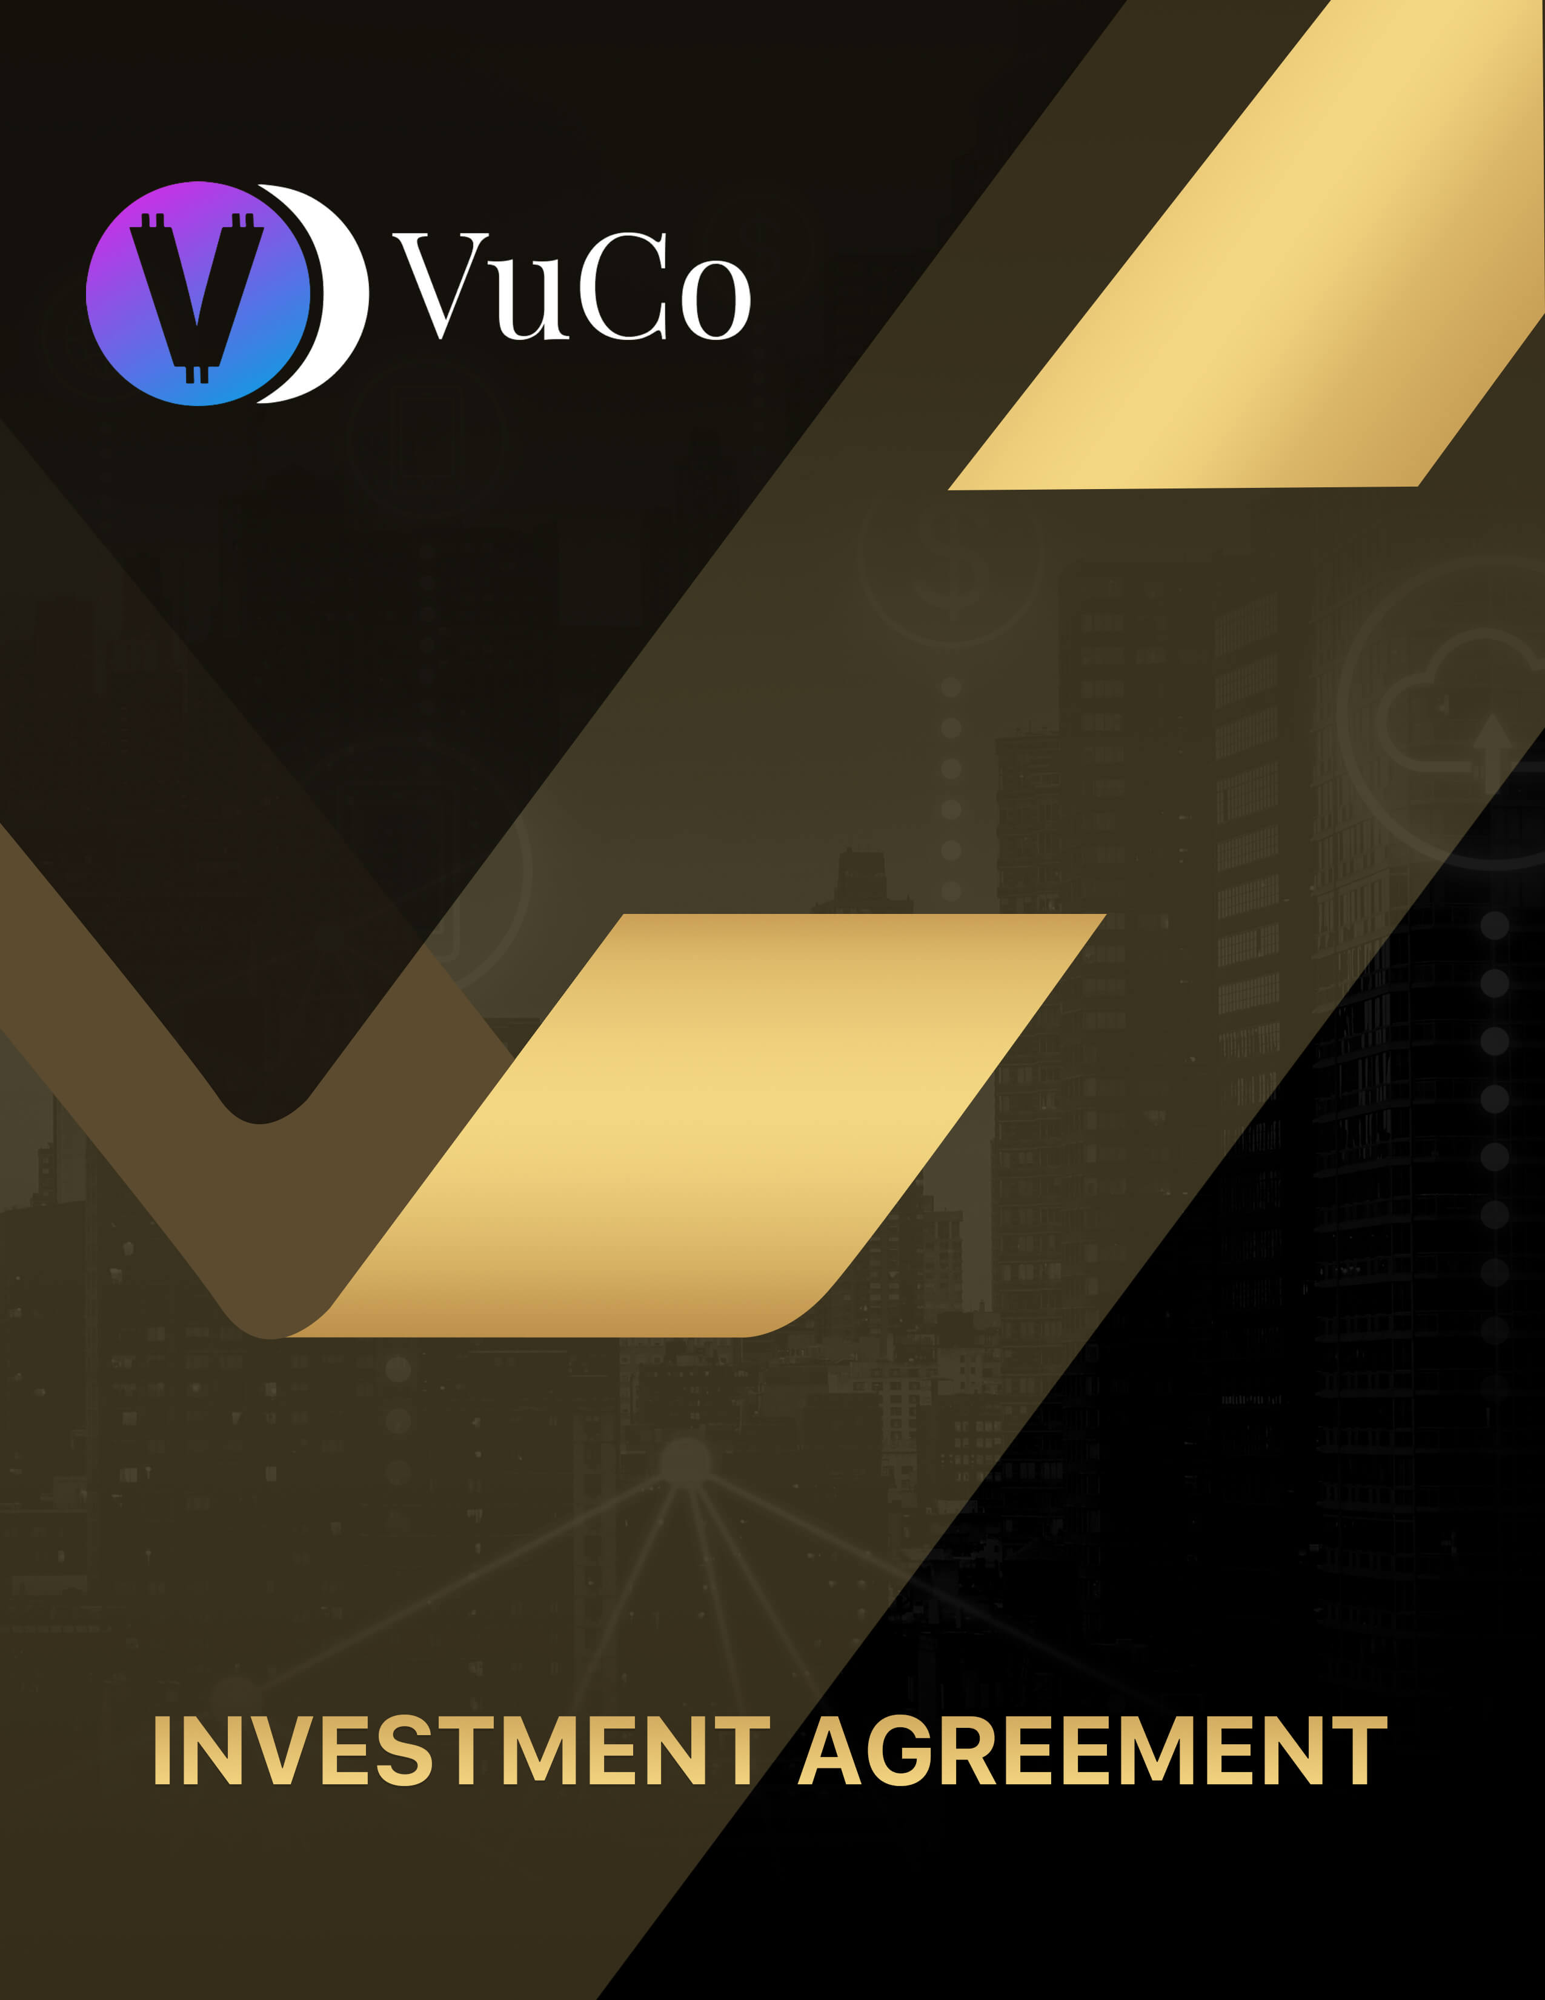
z

INVESTMENT AGREEMENT

between

VUCOCOIN LLC

and

THE INVESTOR

CONFIDENTIAL STO (Security Tokens) MEMORANDUM OFFERED TO ACCREDITED INVESTORS ONLY

VUCOCOIN INVESTMENT IN COMMERCIAL ENTERPRISES & MANAGEMNT CO L.L.C

$137,500,000
25,000,000 VUCO (VUUZLE COINS) TOKENS/COINS

Offering Price: $5.50 per token

Minimum Purchase: 2,000 TOKENS ($11,000)

Total VUCO float: 2,000,000,000

This Confidential STO (Security Tokens) Memorandum (the “Memorandum”) describes the private offering (the “Offering”) by VUCOCOIN INVESTMENT CO LLC, a RAK ICC UAE corporation (the “Company,” of a maximum of 25,000,000 VUCO (VUUZLE COINS) tokens (the “Maximum Offering”) of our Security Tokens at a price of $5.50 per token (the “Offering Price”). This Memorandum is being distributed to prospective investors in order to fully evaluate the risks of this investment. The Security Tokens/Coins are being offered to an unlimited number of accredited investors only on a “best efforts” basis by our management personnel on our behalf.

VUCOCOIN is a holding company that holds the assets for the consortium. Shareholders will receive VUCOCOIN/ special tokens for future trading on CRYPTO CAP TRADES, www.cryptocaptrades.com. Special tokens will allow the purchase of ERC1155 special digital land in VUCO WORLD. Tokens received have been created with smart contracts on the blockchain under ERC20. VUCOCOIN will begin trading when UNISWAP has been connected to our license. All purchases for VUCOCOIN can be either wire, check or CRYPTO wallet transfer. Checks issued need to be written out to either VUUZLE FILM PRODUCTION with license # 883433 DUBAI UAE or GAMEVU INC with RAK ICC # icc20211289.

All wires need to be sent to:

- 56A: Intermediary Institution – BIC
SWIFT Code: COBADEFFXXX
Bank Name: Commerzbank AG
Bank Address: Frankfurt AM Main

- 7A: Account with the Institution
SWIFT Code: MBBEMYKLXXX
Bank Name: Maybank, Labuan Branch
Bank Address: FPL, JLN Merdeka, 87000, Labuan FT, Malaysia

- 59: Beneficiary Customer – Name & Address
Account Number: 765125000724
Account Name: Credit Investment Bank Ltd.
Address: Unit Level 9A (2), Main Office Tower, Financial Park Labuan, Jalan
Merdeka, 87000, Labuan FT, Malaysia

- 70: Remittance Information:
Investment fund placement with CIB (under Vucocoin FZCO A/c No 2000-0002-0022)

Note: Fields 57A, 59, and 70 are mandatory.

All CRYPTO wallet transfers need to be sent by using ETHEREUM:

- VUCOCOIN ETHEREUM WALLET NO.: 0x96B2748450DC785120D03EcA604EC200A8F77618

This investment agreement dated (the Agreement) is entered into by and between:

- The entity or entities whose names and particulars are prescribed in Schedule 1 Part 1 (herein referred to as the Company)
- The entity, entities or person(s) whose name and particulars are prescribed in Schedule 1 Part 3 (herein referred to as the Investor).
The Company and Investor shall be collectively referred to as the Parties and individually as Party.

RECITALS:

- The Company is an international business company, incorporated at the Ras Al Khaimah International Corporate Centre (the RAKICC) in the United Arab Emirates on SEPTEMBER 26 2021, license # 986353. The Company is a holding company that is holding the assets for the consortium.

- The Investor understands based on his independent research and market study that VUCOCOIN is a dynamic and growing group of companies in the media entertainment, crypto, NFT and METAVERSE industry with robust technology and state of the art infrastructure. Accordingly, the Investor has expressed their interest to invest funds in the Company, on behalf of the Company, has agreed to provide a return on investment in line with the terms contained herein.

- The Parties have, therefore, agreed to effectuate the transaction in the manner prescribed hereunder.

THE PARTIES AGREE THAT:

  - Definitions and Interpretation
    - In furtherance to the terms that have been defined elsewhere in this Agreement, the following terms shall have their respective meanings:

Affiliate
Means any person or entity now or hereafter in control, controlled by or in common control with VUCOCOIN LLC.

Applicable Law
Any decree, law, regulation, statute, treaty, convention, implementing regulations, policies, guidance and other orders issued by a Relevant Authority or an authority that has jurisdiction over an agreement which a Party has access or consented to.

Confidential Whole, parts or
Information
related information of any written, verbal, electronic or other form of data, documents and information (including financial information) belonging to, in custody of or generated by the Parties, its members, shareholders, employees, directors, Affiliates, agents, sub-contractors and subsidiaries.

Relevant
Authority A competent legislative, executive or judicial authority with jurisdiction over the subject matter in context including federal government of UAE, government of individual Emirate, ministries, local and federal courts, tribunal, municipality, regulators or other authorities.

Transfer To other way subject to any
transfer, sell, assign, gift, pledge, create a security interest or lien on, place in trust, transfer by operation in law or in any encumbrance or dispose of, whether voluntarily or otherwise
UAE United Arab Emirates

1.2 The Parties agree that the provisions of this Agreement shall be interpreted after taking the following into consideration:
- Pronouns are used interchangeably and their cognate variations shall have the same meaning, unless stated otherwise.

- The term ‘includes’ or ‘including’ shall impliedly mean include or including without limitation.

- The meaning of any provision should be construed in accordance with the heading, subheading and clause references of that provision.

- Any forms, schedules and recitals herein shall form an integral part of this Agreement.

- References to singular terms shall mean and include the plural of such terms and vice versa, unless stated otherwise.

- References made to grammatical tenses (past tense, present tense and future tense) are used interchangeably and their cognate variations shall have the same meaning, unless stated otherwise.

- Any term that is defined but has been referred to in lowercase within this Agreement shall bear the literary meaning of such term. In the event the literary meaning of such term is not appropriate in the given context, the meaning shall be construed after taking the heading, subheading or clause references of that provision into consideration.

Effective Date

The Agreement shall be effective and binding between the Parties on the earlier of (i) the date signed by the Parties; (ii) the date the funds are transferred as stipulated in this Agreement; or (iii) expiry of a period of seven (7) days after VUCOCOIN LLC MANAGEMENT sends this Agreement to the Investor in the event the Investor does not raise any objection(s) to the terms prescribed herein.

Investment and Disbursement of Funds

    - The Investor declares that he has conducted an independent, full, and comprehensive legal and financial due diligence on VUCOCOIN LLC prior to agreeing to the terms of this Agreement and rendering the investment. The Investor, further self attests that he is a seasoned and qualified investor and understands financial markets, the business operations of the Company and regulations, and Applicable Law surrounding his investments and the business operations of VUCOCOIN LLC.
    - Prior to entering into the proposed investment, the company has disclosed all future business and investment propositions of the Company, including the program to tokenize the Company’s assets, infrastructure and business operations, and the Investor understands the same.

    - The Investor understands that his investment in the Company involves a significant degree of risk and that the market price of the proposed tokens (or digital coins) (as mentioned in clause 4) shall be volatile, that no representation is being made as to the future value of such tokens (or digital coins) and that the Investor has carefully read and considered the matters. The Investor undertakes that he has the knowledge and experience in financial and business matters as to be capable of evaluating the merits and risks of the investment and has the ability to bear the economic risks of an investment in the Company. The Investor has had a reasonable opportunity to ask questions of the Company and its representatives; and the Company has answered all inquiries that the Investor or the Investor's representatives have put to it, and all such inquiries have been answered to the full satisfaction of the Investor.

    - The Investor acknowledges that he has obtained individual legal and financial advice on the investment mentioned herewith and agrees to invest the sum (as prescribed and in the manner set out in Schedule 2) with the Company. In return for the said investment, the Company agrees to provide return on investment as per the terms of clause 4 of this Agreement.

    - The Parties confirm that the Company and administration is and remains compliant with all registration and licensing formalities of the RAK ICC and Dubai Economic Development and that all necessary forms and documents have been completed and submitted as required.

  - The Parties agreed and confirmed that the company has undertaken responsibility for the management, operation, and administration of the Company.
The Investor, based on his independent research and analysis, understand that the company possess the requisite skills, knowledge, experience, capacity and
capabilities necessary for the effective management, operation, and control of the Company.

- Distribution of Profits and Losses

4.1. The Investor has agreed, to tokenize the Company’s assets, infrastructure and business operations through a regulated fintech company (the Proposed Company) that shall be incorporated at the Abu Dhabi Global Markets or a similar jurisdiction of the company choice. The Proposed Company shall form part of the VUCOCOIN LLC as soon as the license towards the same is issued for the same by the Relevant Authority.

4.2. Based on the assertions made by the company in clause 4.1 above, the Investor shall accept such tokens (or digital coins) from the Proposed Company as assigned by the company based on the extent of investment rendered by the Investor as per Schedule Such tokens (or digital coins) granted by VUCOCOIN LLC through the Proposed Company shall form the consideration in return for the investment by the Investor.

4.3 The Investor understands and acknowledges that he shall not receive, obtain or have access to any shares in the Company or the entities in the company as the sole consideration of the investment by the Investor shall be the proportion of tokens (or digital coins) that he shall receive once the initial coin offering of the Proposed Company is initiated. The Investor wishes to obtain such tokens (or digital coins) to benefit from the anticipated increase in the value of such tokens (or digital coins).

4.4 The company agrees to utilize resources of the Company in an effective and efficient manner in line with Applicable Laws in order to generate revenue and profits of the company that shall, in turn, appreciate the real-time value of the tokens (or digital coins) issued in favor of the Investor.

Corporate Governance

Notwithstanding anything to the contrary in this Agreement, no action may be taken by the Investor and the company without the prior consent of other investors who have invested in the Company and holds tokens (or digital coins) of the Proposed Company namely:
- An amendment to the terms of this Agreement

- The voluntary winding-up, dissolution, merger, amalgamation or re-organization of the Company or entities within the VUCOCOIN Group

- Re-organization, cancellation, subdivision, re-classification or buy back of any tokens (or digital coins)

- Any dealing with the unissued capital of the Company or entities within the VUCOCOIN group.

- The issue of any shares (including any new class of shares) in the capital of the Company or entities within the VUCOCOIN group

- Varying the rights attached to any class of share in the capital of the Company or entities within VUCOCOIN group.

- The incorporation of any subsidiary of the Company or entities within the VUCOCOIN group.

- The amendment or termination of this Agreement

Management

6.1 The Parties hereto agree to the appointment of VUCOCOIN LLC MANAGEMENT TEAM, as full-time Manager of the Company and the entities within the company. Save as otherwise provided in the Agreement, the Investor acknowledges and agrees that VUCOCOIN LLC MANAGEMENT TEAM in its capacity as the manager of the company and the entities within VUCOCOIN group, has the rights to manage and operate the company

6.2 VUCOCOIN LLC MANAGEMENT TEAM shall at all times act in the best interest of the Company and the entities within the VUCOCOIN group. VUCOCOIN LLC

MANAGEMENT TEAM agrees and acknowledges that in his capacity as the Manager of the Company, they shall not carry out any acts or purport

6.3 VUCOCOIN LLC MANAGEMENT TEAM, in their capacity as the Manager, agrees and acknowledges that they shall responsible towards the affairs of management of the Company and the VUCOCOIN group and indemnify, defend, and hold harmless the Investor from any and all liability, loss, or damages they or any of them incur or sustain as a result of any claims, demands, damages, actions, causes of action, judgments, costs or expenses including attorneys’ fees, which results from or arising out of, any willful default or negligence.

6.4 VUCOCOIN LLC MANAGEMENT TEAM, in their capacity as the Manager, shall appoint a certified auditor to prepare the balance sheet of the Company and entities within the VUCOCOIN group and administer profit and loss account. The auditor shall also prepare an annual report of the activities and the financial position of the Company and the VUCOCOIN group together with their recommendations in relation to the distribution of profits. All these documents must be repaired by the end of every financial year-end and shall be submitted to the Investor for approval.

Operations

Each Party hereby agrees, acknowledges, and warrants as under:

- VUCOCOIN LLC MANAGEMENT TEAM, in their capacity as the Manager of the Company, shall manage the affairs of the Company and VUCOCOIN Group. The VUCOCOIN LLC MANAGEMENT TEAM shall enjoy absolute power and right to carry out the administration and to take any decision with regard to the Company and VUCOCOIN Group. The Investor hereby agrees that it shall have no rights in the management, control, operation and/or administration, operations, and intellectual property and further undertakes to never.

interfere, directly or indirectly, in the management and in the activities of the Company and VUCOCOIN Group.

- VUCOCOIN LLC MANAGEMENT TEAM undertakes and represents to devote a significant majority of his time and attention during business hours exclusively to the business and the duties of their employment including business development and growth of operations of the
Company and VUCOCOIN Group.

- VUCOCOIN LLC MANAGEMENT TEAM shall have the sole right to appoint any employees and staff members in all categories and occupations, as also to determine the salaries and wages of such employees and payment thereof, matters relating to termination of their services, and all responsibilities regarding the employees.

Obligations of the Investor

  - In order to secure the interest of the Company and VUCOCOIN Group, the Investor hereby agrees, acknowledges, and warrants

a.) Not to create, attempt to create, or permit to subsist any interest on the whole or any part of the assets of the Company and VUCOCOIN Group.
b.) Not to take any step or action which may adversely affect the interest of the Company, VUCOCOIN Group.
c.) He shall co-operate with VUCOCOIN LLC MANAGEMENT TEAM for any matters whatsoever relating to the Company or VUCOCOIN Group for which his assistance may be required before any Relevant Authority or in any manner whatsoever.

8.2 The Investor agrees to adhere to all the Applicable Laws and shall not transfer all or any of the tokens (or digital coins) held by them to any third party and any Transfer of such tokens (or digital coins) by Investor in breach of this Agreement, including this Clause 14, shall be null and void ab-initio, and shall not be binding on the Company.

8.3 In order Right to First Refusal: Without prejudice to Clause 8.2 and in consonance with the Laws applicable to this Agreement, if the Investor wishes to Transfer all or any part of the tokens (or digital coins), the Investor will offer to VUCOCOIN LLC MANAGEMENT
TEAM, right of first refusal to purchase such tokens (or digital coins) and shall send a written notice which shall state:

(i) the number of tokens (or digital coins) (ii) the amount and form of the proposed consideration for the Transfer, (iii) the other terms and conditions of the proposed Transfer. The company shall have the right, exercisable at his sole discretion, to elect to purchase by the issuance of a notice in this regard to the Investor within 45 (forty-five) days from the receipt of the notice at the mutually agreed price, terms, and conditions.

8.4 If the Investor fails to perform any of the undertakings contained in this Agreement, the company may remedy any such failure at the Investor’s expense whether by himself or through any other person, that he considers to be appropriate without, in any event, becoming liable to account to the Investor.

- Conduct of the Parties

Compliance: VUCOCOIN LLC MANAGEMENT TEAM shall ensure that the Company shall:

- comply with all Applicable Laws of the UAE and regulations and guidelines set out by Relevant Authorities from time to time.

- do or cause to be done all things necessary to obtain and maintain in force all authorizations from Relevant Authorities which may at any time be required under the laws of the country of its incorporation, organization, or operation to enable it to conduct its businesses in accordance with the terms of this Agreement and any decisions of the Parties taken pursuant thereto.

- pay all taxes, assessments and other governmental charges of any kind imposed on or in respect of its income, gains, businesses or assets before any lien on the property of any of them exists as a result of non-payment, provided that nothing shall require the Company to pay or withhold any amount.

- the Parties shall, at all times conduct their affairs in such manner as shall promote and develop the interests and business, and optimize the value, of the Company, in accordance with good business practice

Termination

This Agreement and the provisions contemplated herein may be terminated at any time in following events:

      - Upon the dissolution or liquidation of the Company by any court order or at the option of all the shareholders.
      - If the Investor (defaulting Party) have committed any material breach of this Agreement and if such breach is not remedied within 45 (forty-five) days of service of written notice by VUCOCOIN LLC MANAGEMENT TEAM to the defaulting Party or where such breach is not capable of being remedied, the company shall have the right to terminate this Agreement forthwith by giving notice in writing to the defaulting Party.
      - If VUCOCOIN LLC MANAGEMENT TEAM is unable to incorporate the Proposed

Company and issue the proportion of tokens (or digital coins) in favor of the Investor within a reasonable time period.

Consequences of Termination

    - In the event that the Agreement is terminated in accordance with Clause 9.1, the total proceeds from such liquidation, after discharging or making provision for discharging the liabilities of the Company, shall be distributed in accordance to the ratio of the investments made by the Investor against the total investment made in favor of the Company by other investors.

    - In the event that the Agreement is terminated in accordance with Clause 9.2, VUCOCOIN LLC MANAGEMENT TEAM may remedy any such material breach at the Investor’s expense whether by himself or through any other person, and recover all the tokens (or digital coins) issued in favor of the Investor, with immediate effect.

    - In the event that the Agreement is terminated in accordance with Clause 9.2, the Investor understands that VUCOCOIN LLC MANAGEMENT TEAM shall not be mandated to return the investment amounts considering the time, effort, and money invested by VUCOCOIN LLC MANAGEMENT TEAM towards incorporating the Proposed Company and issuing the proportion of tokens (or digital coins).

- Confidentiality

  - The Investor shall at all times use its best endeavors to keep in strictest confidence and not divulge, communicate or disclose to any person or use or exploit for its own purposes or those of any other person any information of a confidential nature made known or acquired by it at any time and relating to the Company and the VUCOCOIN Group, without the prior written consent of VUCOCOIN LLC MANAGEMENT TEAM.
  - The Investor shall be entitled to make or permit or authorize the making of any press release or other public statement or disclosure concerning this Agreement or any transaction contemplated by it or its termination or cessation without the prior written consent of the other party, except as required by any regulatory or other Relevant Authority, but before either party makes any such release, statement or disclosure it shall first supply a copy of it to the other and shall incorporate any amendments or additions it may reasonably require.

General

  - No Assignment: The Parties may not assign any benefit afforded under this Agreement unless prior written consent of the other Parties has been obtained under this Agreement.
  - No Waivers: Any act, or failure to act, which constitutes a breach of this Agreement may be considered as a waiver of this Agreement. All rights, responsibilities and duties assigned in this Agreement remain in place in the event of a breach until removed by amendment.
  - Whole Agreement: This Agreement and any additions, exhibits, or amendments thereunto will constitute the entire agreement between the Parties, and shall supersede all previous agreements, whether written, oral, or implied through conduct. The Parties confirm that they relinquish all rights awarded outside of this Agreement, and consent to be bound by this Agreement hereafter.
    - Unlawful Provisions: If any individual provision contained within this Agreement is held to be unlawful the offending provision shall be removed, with the effect that the remainder of the Agreement shall remain in force and will continue to bind the Parties.
    - Notices: Each notice, letter, request, or other communication given or made under this Agreement shall be in writing in the English language and delivered or sent to the relevant Party at its physical address and email address (or such other address as the addressee has specified in writing to the other Party). Any notice, demand or other communication given or made by letter between countries shall be delivered by registered airmail or international courier service. Any notice, demand, or other communication so addressed to the relevant Party shall be deemed to have been delivered
- if delivered in person or by messenger, when proof of delivery is obtained by the delivering Party, (ii) if sent by courier and proof of delivery is available through online (or other) tracking methods of such courier company, and (iii) if sent by email andthe other Party acknowledged receipt of such email.

Governing Law and Dispute Resolution

This Agreement shall be governed by, and construed in all respects in accordance with the laws of the Dubai and in the event of any dispute arising out of this Agreement, the Dubai Courts shall have exclusive jurisdiction.

In witness whereof, the Parties have agreed to the abovementioned provisions on the date prescribed on the second page of this Agreement.

VUCOCOIN LLC

The Company

Date:

The Investor

Date:

Part I: The Company
Name | VUCOCOIN LLC
Registered Office | RAK INTERNATIONAL CORPORATE CENTRE GOVERNMENT OF RAS AL KHAIMAH
License and Registration | #986353
Part III: The Investor
Name
Nationality and Passport/SSN or Driver license number:

Investment
VUCO (Vuuzle coin) purchase price | $
Tranche | Number of Vuco (Vuuzle coin):
 | INVESTMENT AMOUNT $:

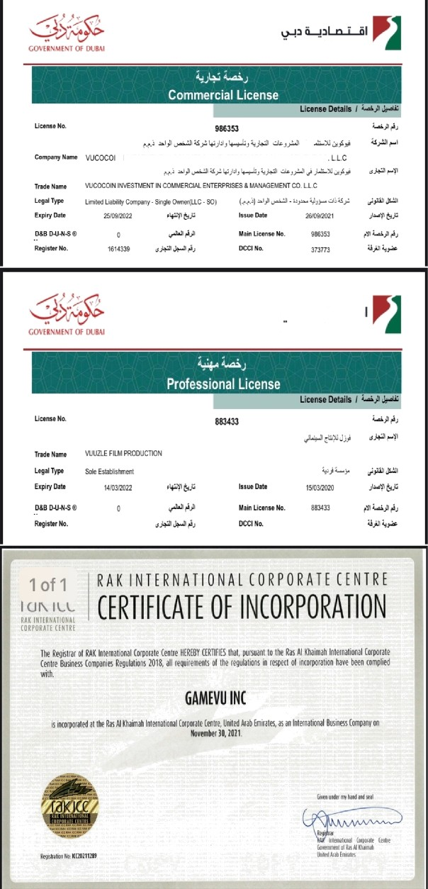
DUBAI ECONOMY
N INYESTPlENT IN COIyIMERCIAL ENTERPRISES 6 ktANAGEMENT CO
DUBAI ECONOMY

